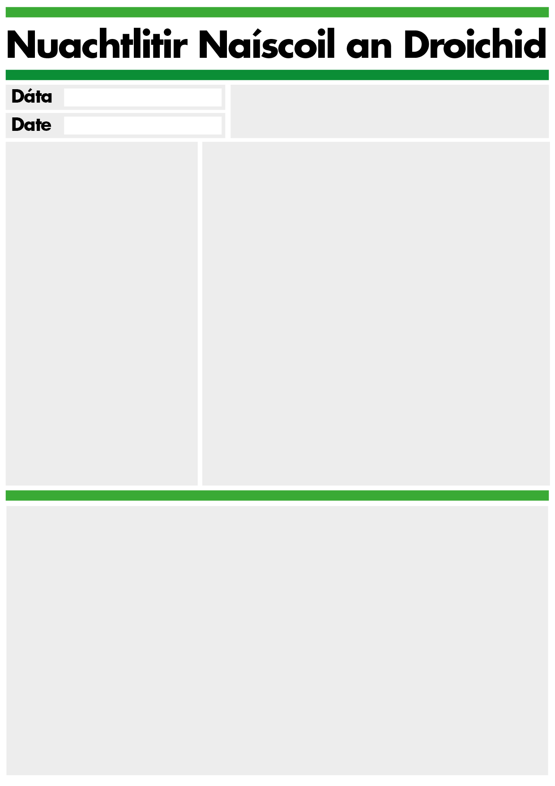
Fáilte go Naíscoil an Droichid.
The Naíscoil times are 9:15 to 1:45 for all children who are ready to stay for the full day. Although the school day doesn’t start until 9:15 we can welcome children into the class from 8:45 when the breakfast club finishes. If you wish to book a place in the breakfast club which opens at 8:00, please speak to Sinéad in the office.
Please pay weekly fee of £5 directly to Sinéad and any other money such as dinner money or breakfast club fees. If you can’t get to the office please put money in an envelope in the hall with date, child’s name and amount clearly written on it.

We encourage healthy eating in the Naíscoil and at lunchtime children drink milk or water which we provide. We suggest that children’s lunches include some of the following: sandwich or crackers or pasta, fruit, cheese and yogurt. Please try not to include jam or Nutella as a filling. Be aware that our school is a nut free zone due to allergies. We will provide a biscuit on Fridays as a treat.

POur

We encourage good choices/ roghanna maithe in the Naíscoil and we remind the children that they can always turn a bad choice/ rogha olc into a good choice/ rogha mhaith. We celebrate good choices and use visual representations to help the children understand this concept.
On Thursday afternoons we celebrate good choices with Golden Time / Am Órga when the children play with our special toys.
We are very lucky to have a great team of volunteers and trainees helping in our class. After Halloween we offer parents the opportunity to spend a morning in class also. Contact Dunla if you are interested in coming in.
Deireadh Fómhair 19
October 19
Lón/Lunch

Helping your child to become more independent
Ag cothú neamhspléachas i do pháiste

It is important to let your child practice self-help skills like putting on their own pants, socks and trousers. If your child has a toileting accident at school or if they spill water/milk at break or lunch time they will be encouraged to change their own clothes. Please make sure that shoes are easy for them to take off and put on. It is also helpful if you keep a change of clothes for your child in a bag on their peg at school or in their schoolbag. If spare clothes from school go home with your child, please return them as soon as possible as we have limited supplies.
Coats/ cótaí We play outside everyday- before the cold weather sets in help your child practise putting their coat on without help and taking it off.
Please put your child’s name on all coats, jumpers, bags etc
Teeth /Fiacla Children clean their teeth at school as part of the healthy smiles project. Regular packs of a toothbrush and toothpaste will be sent home as part of this scheme.

There will be short parent meetings on the 29th November to review how your child has settled in and the Naíscoil will be closed on this date.
There will be an Irish language workshop on 24/10/19 9:15-10:30 to help learn some of the basic phrases we use with the children.
We are working with our school Health Visitor, Eimear Gilleece, this year, as part of an Early Intervention scheme to support families. Eimear will be distributing information on child development, along with some short questionnaires for parents and will follow this up with meetings on Tuesday 12th and Wednesday 20th November. We are also liaising with SureStart to facilitate some workshops on child development later in the year.

Birthdays At the end of every month we will celebrate any birthdays that fell during that month with a birthday cake. At the end of September month we celebrated birthdays from July, August and September. Breithlá sona do Leo, Darragh, Saoirse agus Saoirse, Sorcha, Anton and Abbie
In October we will celebrate Eliza Rose’s birthday.

Events/Imeachtaí
Maths week 14/10/19 Seachtain na matamaitice-focus on shapes
Family day Saturday 19 th Oct/ Lá teaghlaigh 19/10/18 10:30-12
Ceardlann Gaeilge 24/10/19 9:15 -10:30 Irish phrases workshop 24th October 9:15-10:30
Halloween party 24th children dressing up Cóisir na Samhna 24/10/19– páistí ag gléasadh suas. Children at school for full day but not at school on 25/10/19
Naíscoil closed 29/11/19 Naíscoil druidte Aoine 29/11/19 for meetings.

We have a system of captains at each table in the Naíscoil- 6 captains a day. Each child has an opportunity to be the captain in a normal school week. Captains have special roles and responsibilities for helping their group and the children respond very well to this system. It is the captain’s job to look out for good choices during the day: good listening, good sharing, good helping…. And at the end of the day the captains will pick a child from their table to get a prize for good choices. Staff help to make sure that each child will get a prize once a week.

Media Initiative puppets will be going home with the children for a night. Please encourage the children to take responsibility for minding and returning the puppets. A book about the puppets, some information about the scheme and also a dvd will be included with the puppet.
The Media Initiative for Children Respecting Difference aims to:
- Increase awareness of diversity and difference issues
in Northern Ireland among children aged 3-5, their parents and teachers.
- Help young children to understand
what it feels like to be excluded and encourage them to be more willing to include children who are different from themselves.
- Encourage young children to demonstrate respect
and the active inclusion of others who are different, rather than ridiculing, fighting or rejecting them.
- Make Respecting Difference
a very real experience for young children and something that can be shared with their families
- 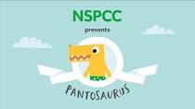 PANTS Project NSPPC
- We will be introducing the PANTS programme to the children and sending home information about it to parents.
- We feel that this is a very valuable project for keeping children safe and also on a basic level for us in the Naíscoil when we are encouraging children to pull up pants and trousers before they come out of the cubicle when using the toilet at school. You can look at the resources online if you go to the NSPPC website.

